1.Generation of number series 1, 2, 3, 4,…..n .

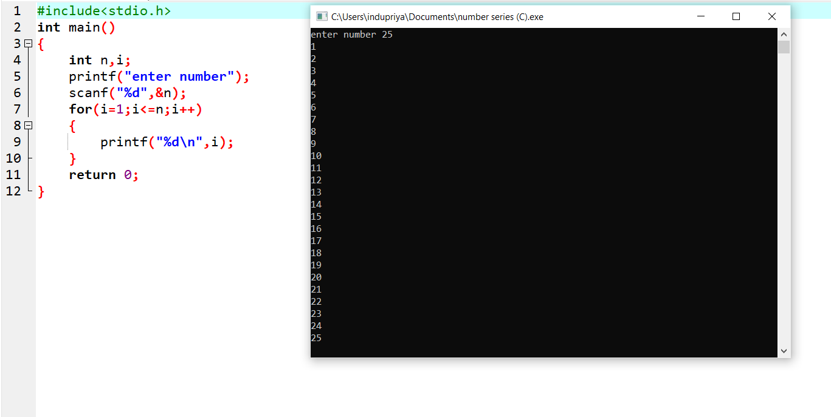C PROGRAMMING:

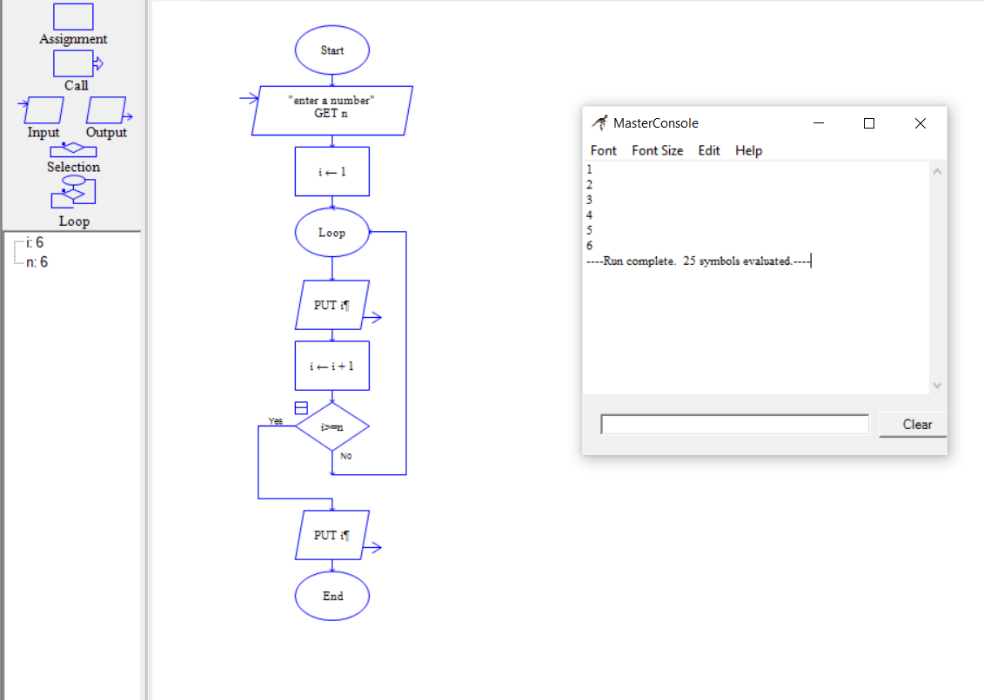RAPTOR FLOWCHART:

2.Generation of even number series 2, 4, 6, …..n .

C PROGRAMMING:

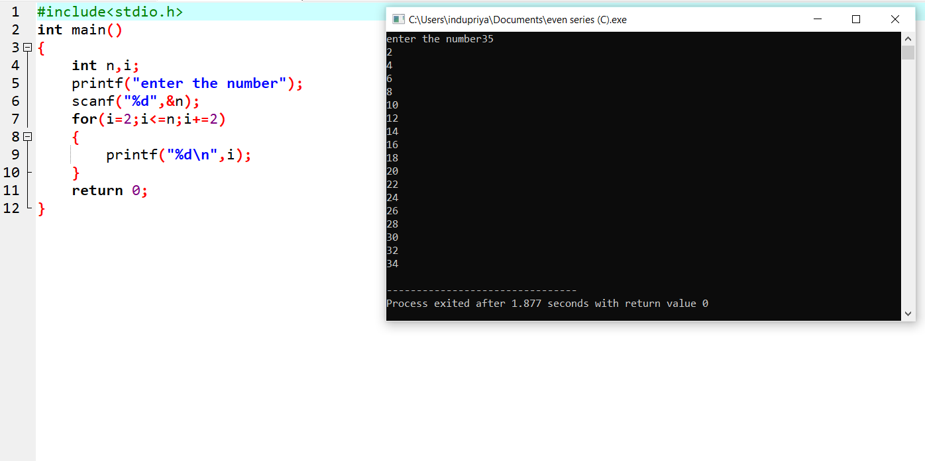

RAPTOR FLOWCHART:

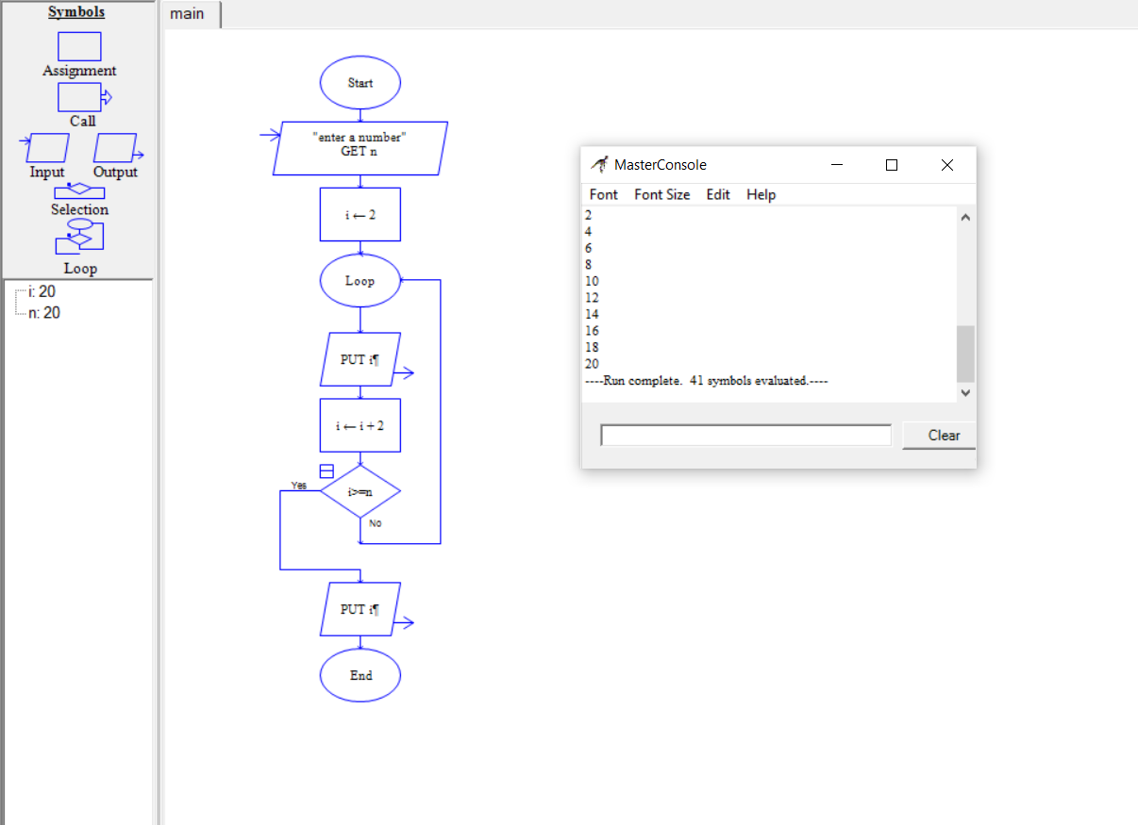

3.Generation of odd number series 1, 3, 5, …..n .

C PROGRAMMING:

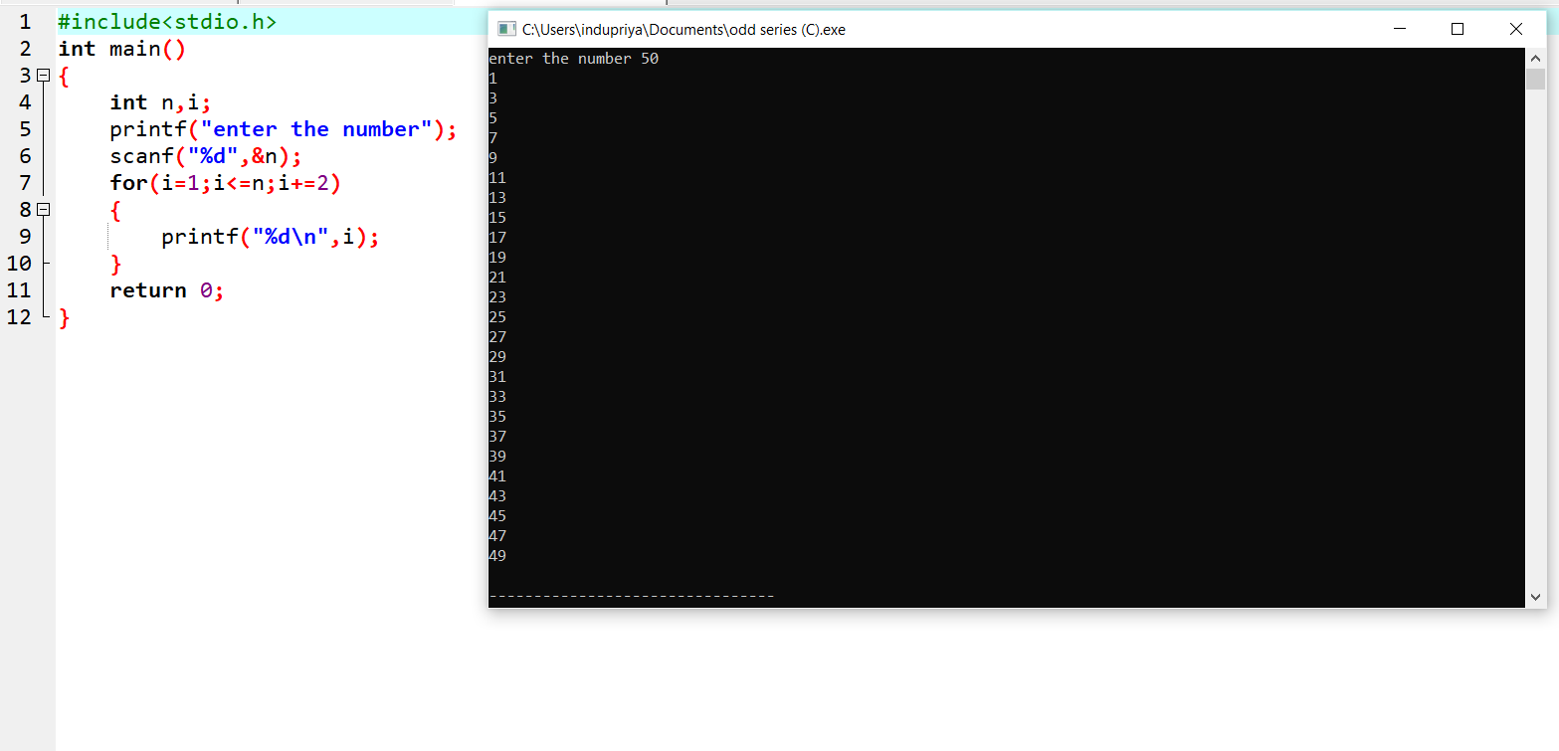

RAPTOR FLOWCHART:

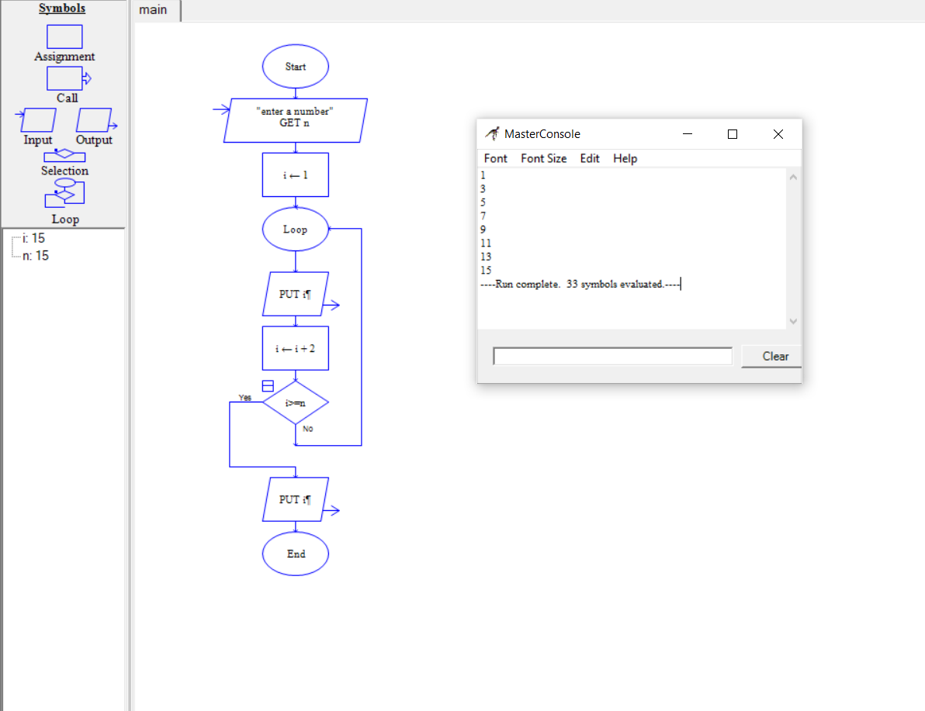

4.Summing up series 1 + 2 + 3 + 4….. +n .

C PROGRAMMING:

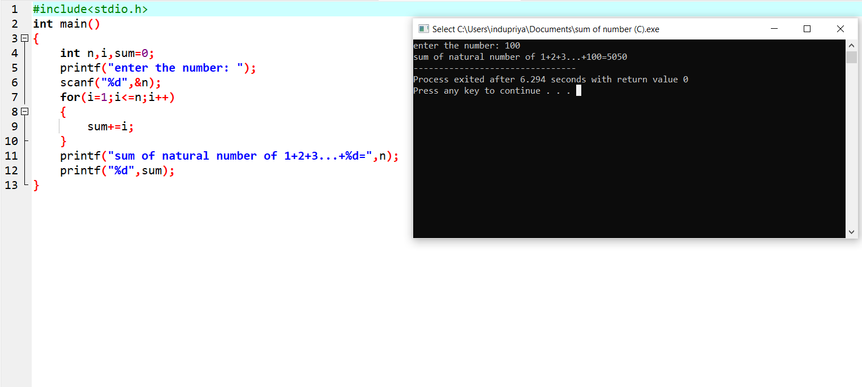

RAPTOR FLOWCHART:

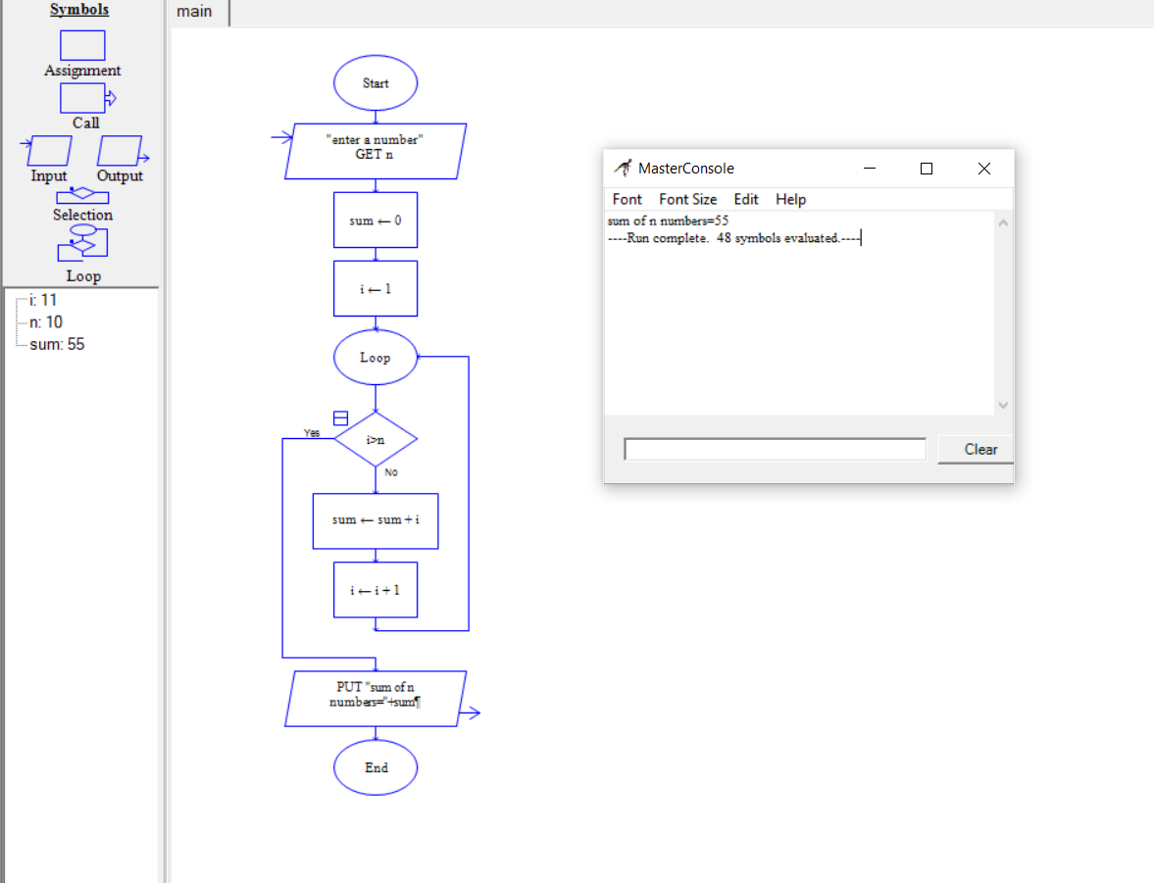

5. Summing up even number series .

C PROGRAMMING:

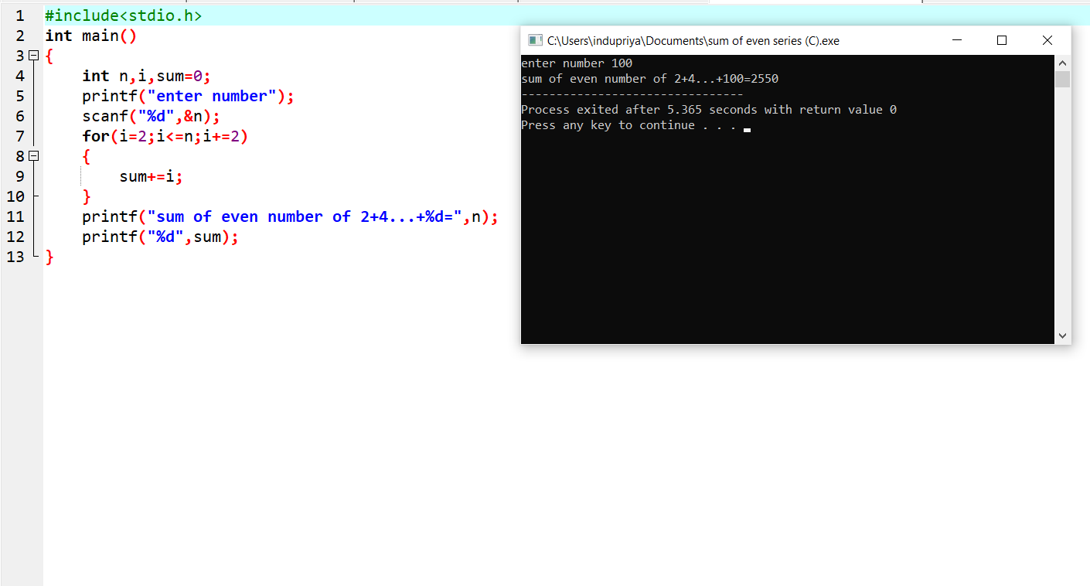

RAPTOR FLOWCHART:

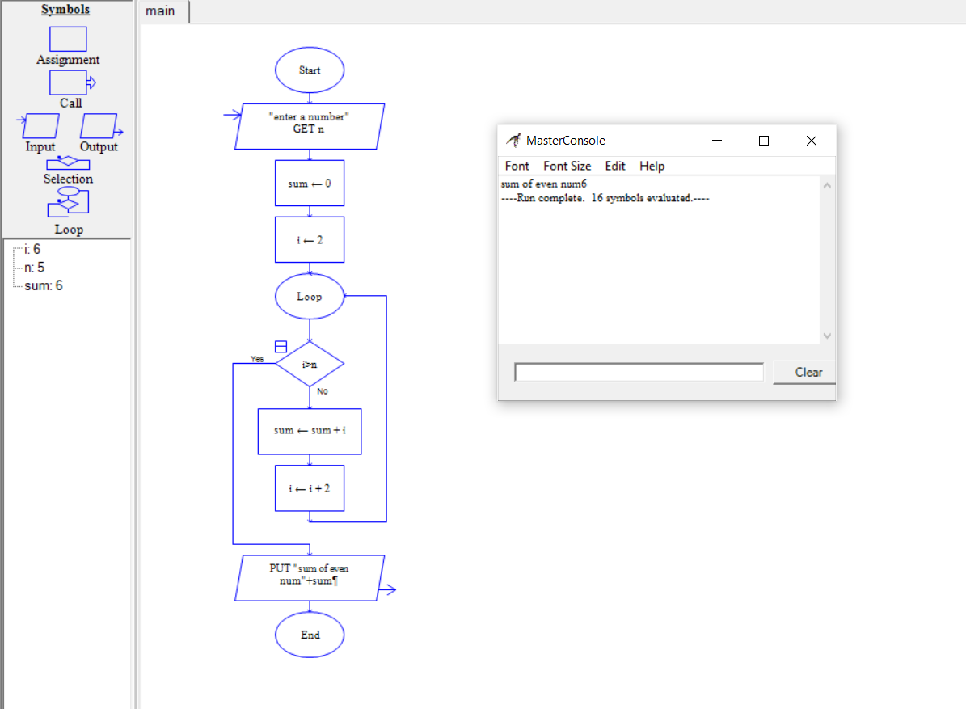

6.Summing up odd number series .

C PROGRAMMING:

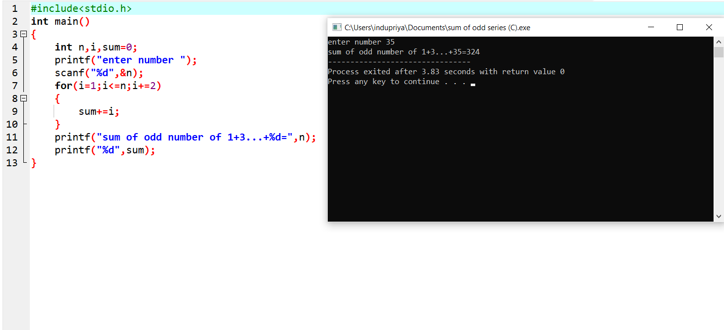

RAPTOR FLOWCHART:

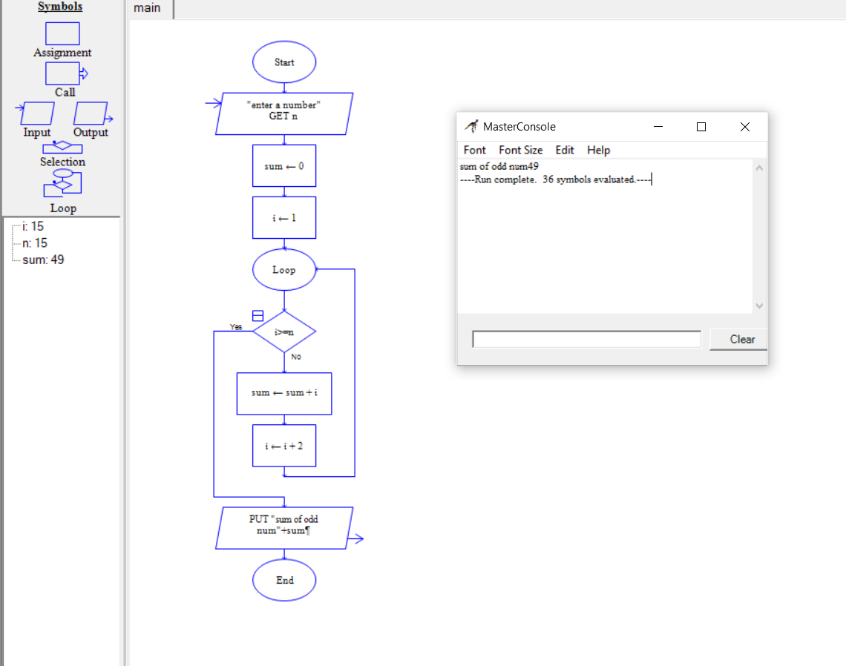

7. Summing up square of n number.

C PROGRAMMING:

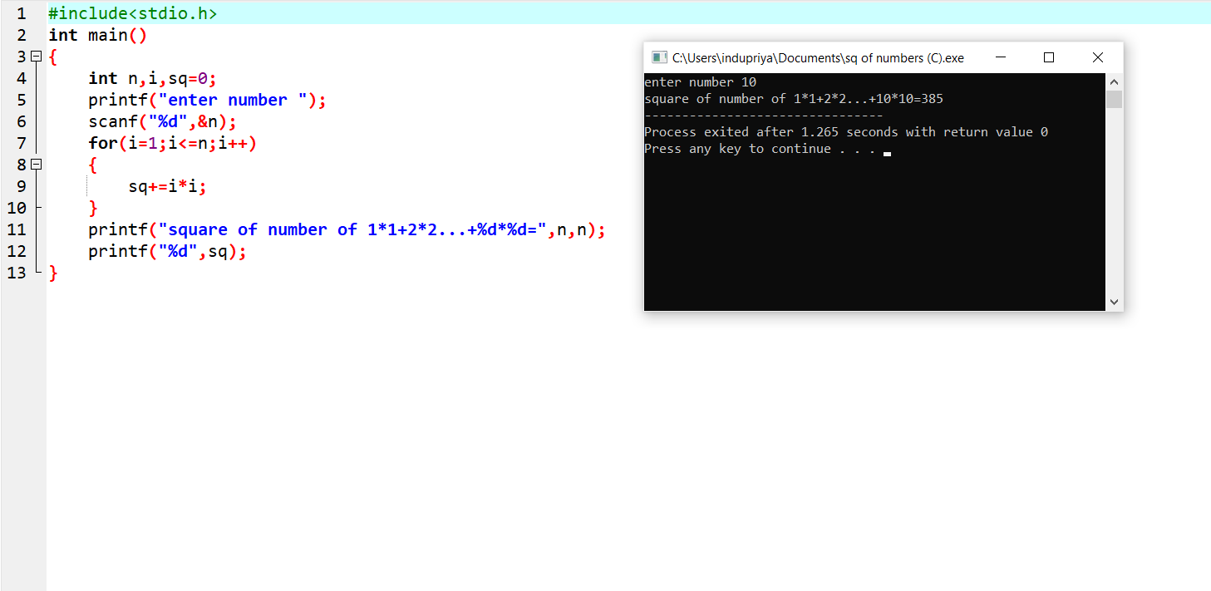

RAPTOR FLOWCHART:

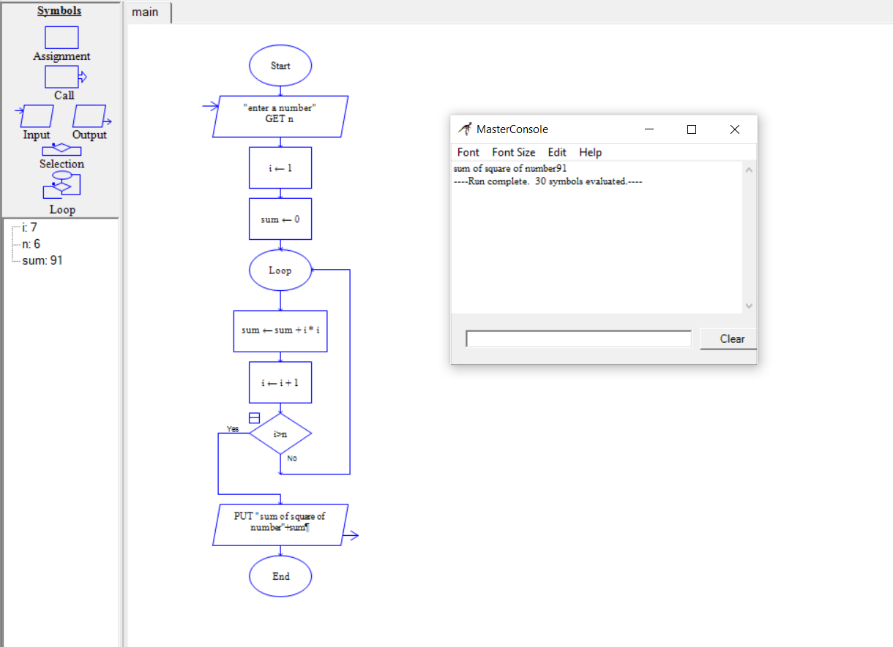

8.Summing up square of even number series .

C PROGRAMMING:

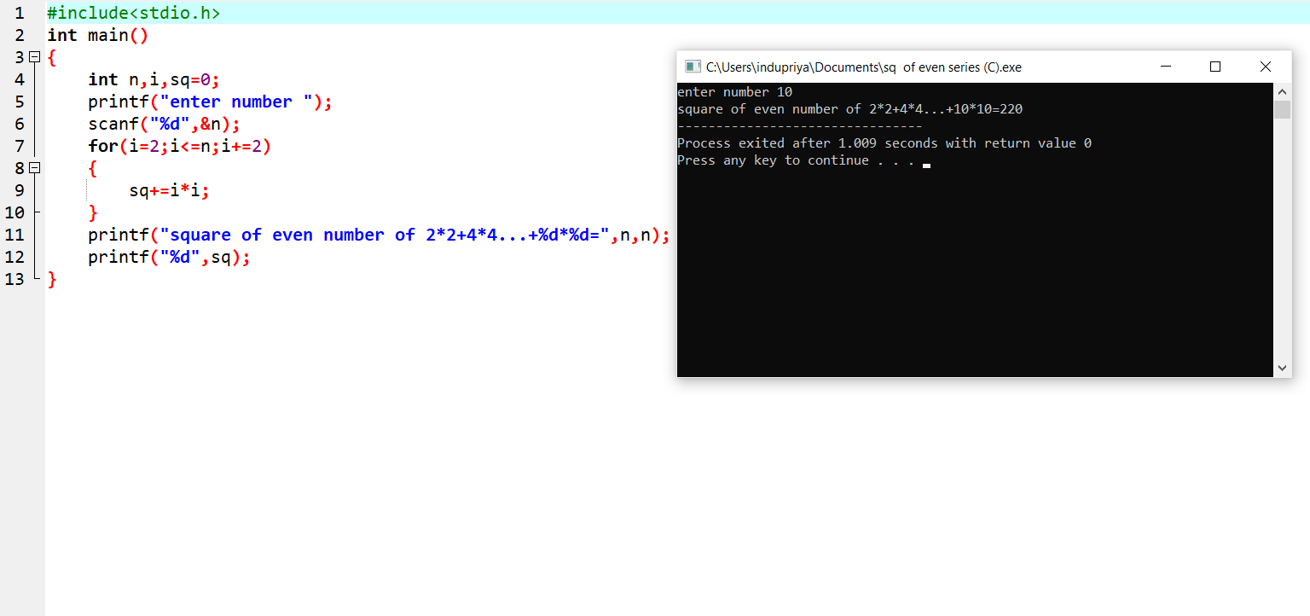

RAPTOR FLOWCHART:

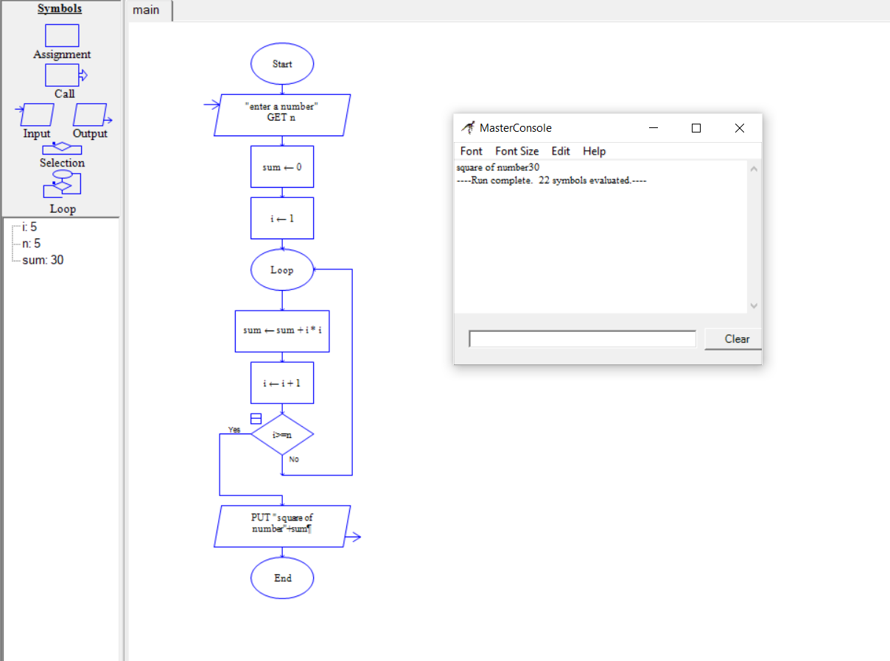

9.Summing up square of odd number series .

C PROGRAMMING:



RAPTOR FLOWCHART:

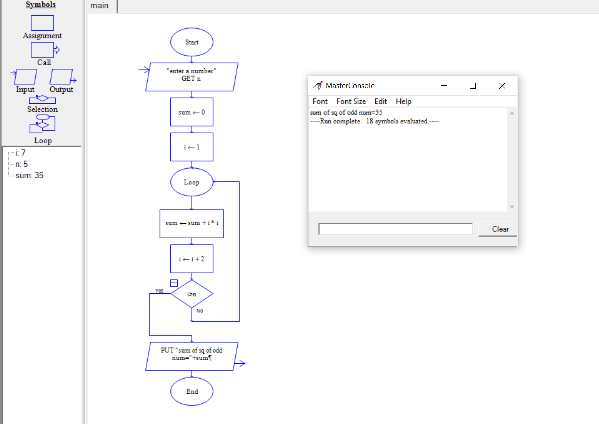

10.Summing up cubes of n numbers.

C PROGRAMMING:

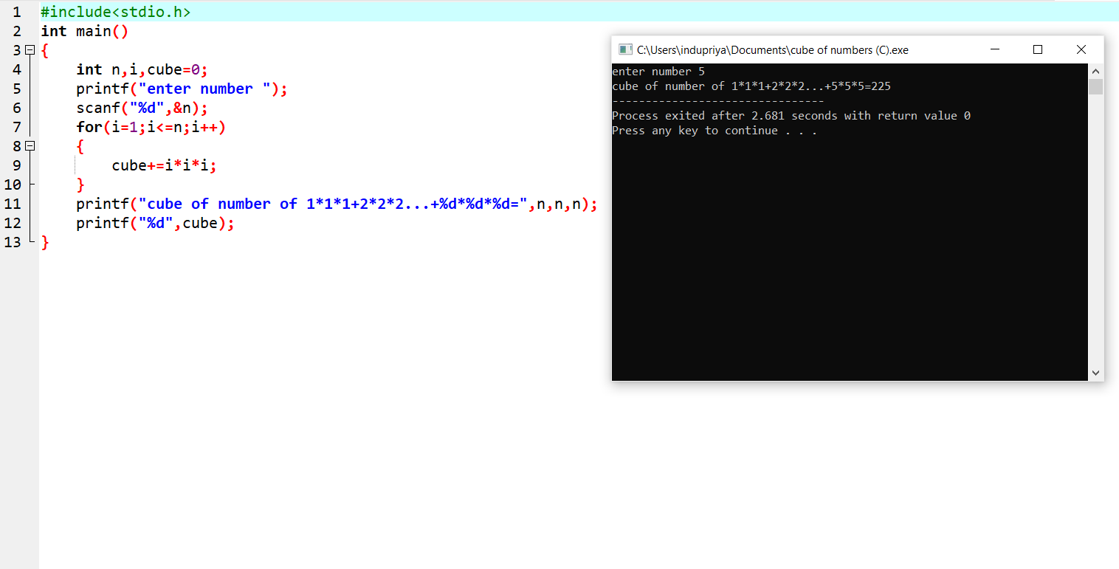

RAPTOR FLOWCHART:

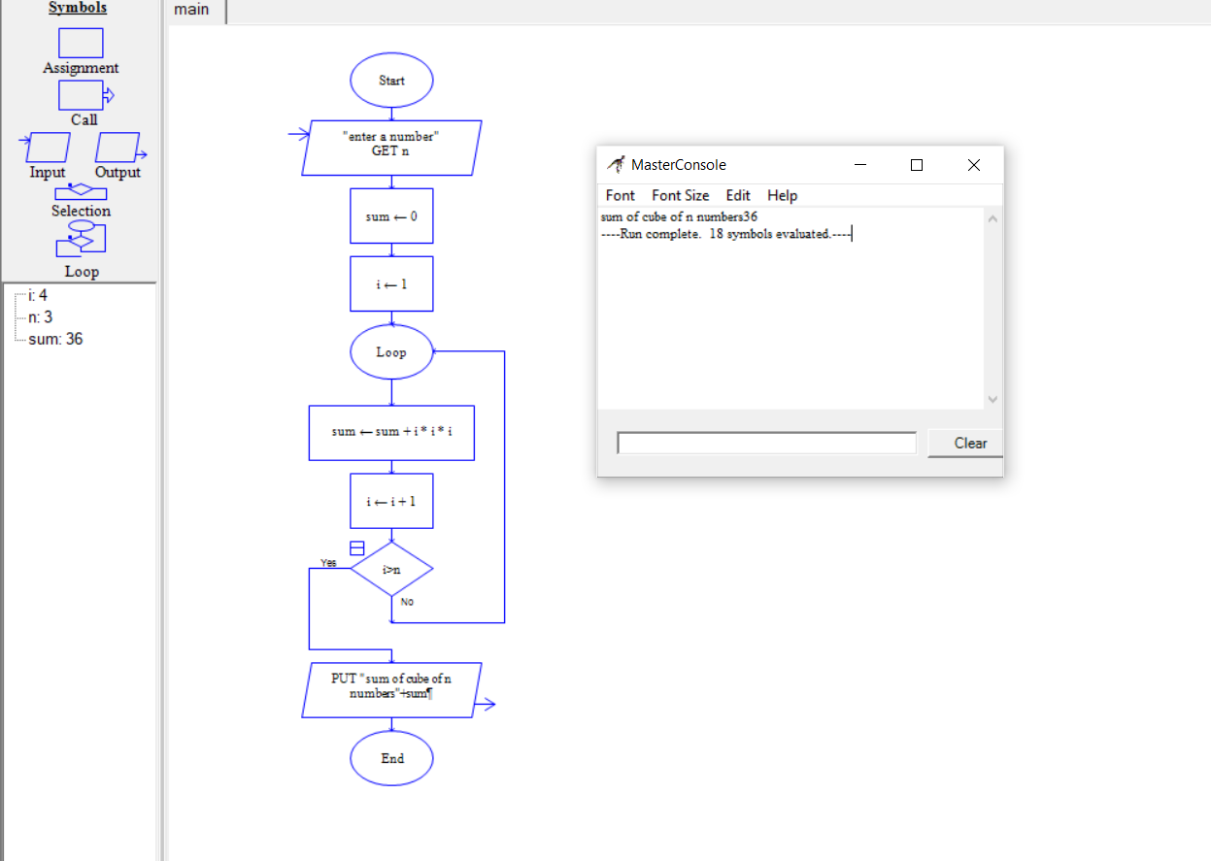

11.Summing up cubes of even number series .

C PROGRAMMING:

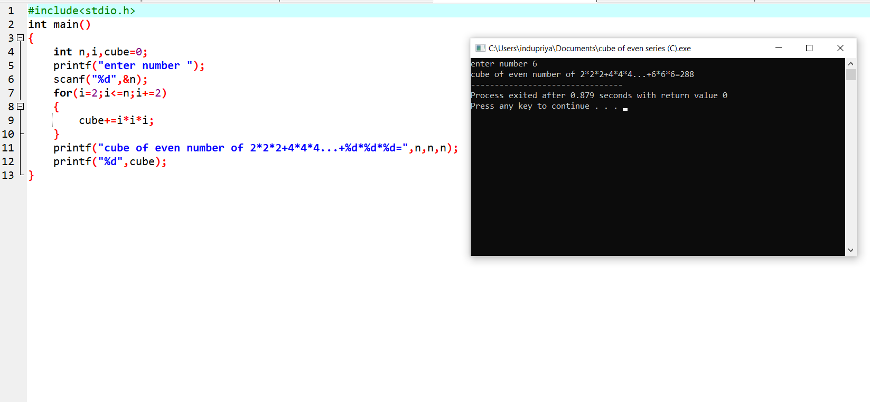

RAPTOR FLOWCHART: 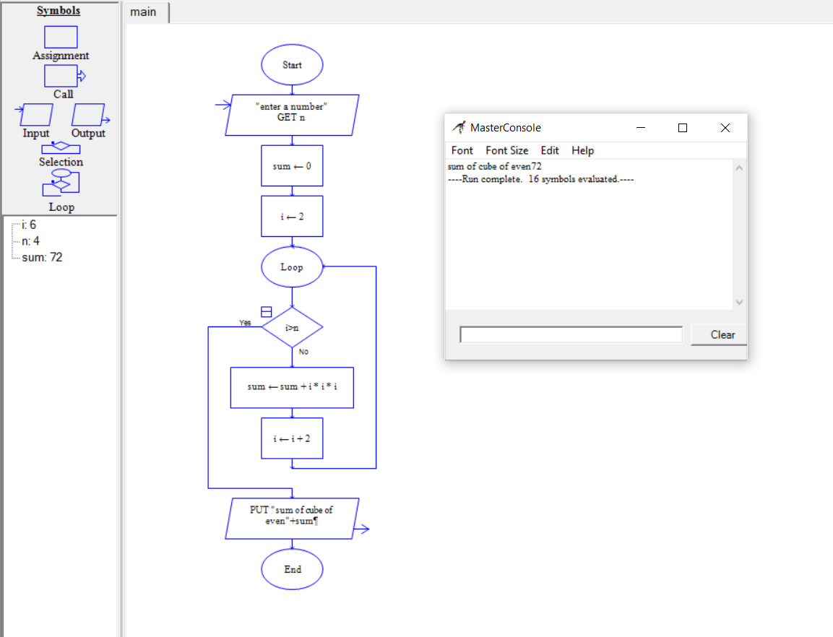

12.Summing up cubes of odd number series.

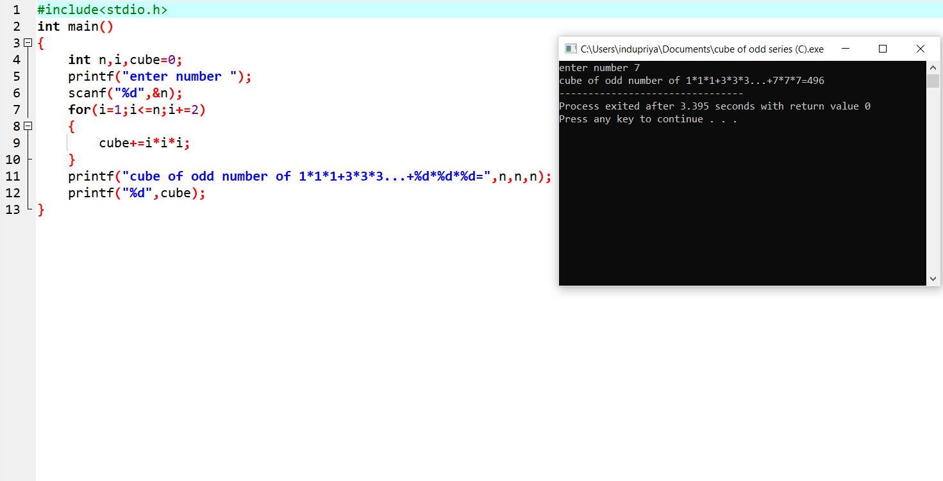C PROGRAMMING:

RAPTOR FLOWCHART: